Name: Jerameel M. Gamo Jr. BS INFO-TECH 2-A

**Nava Natiional High School Event Management System**

**System Flow**

Login Form

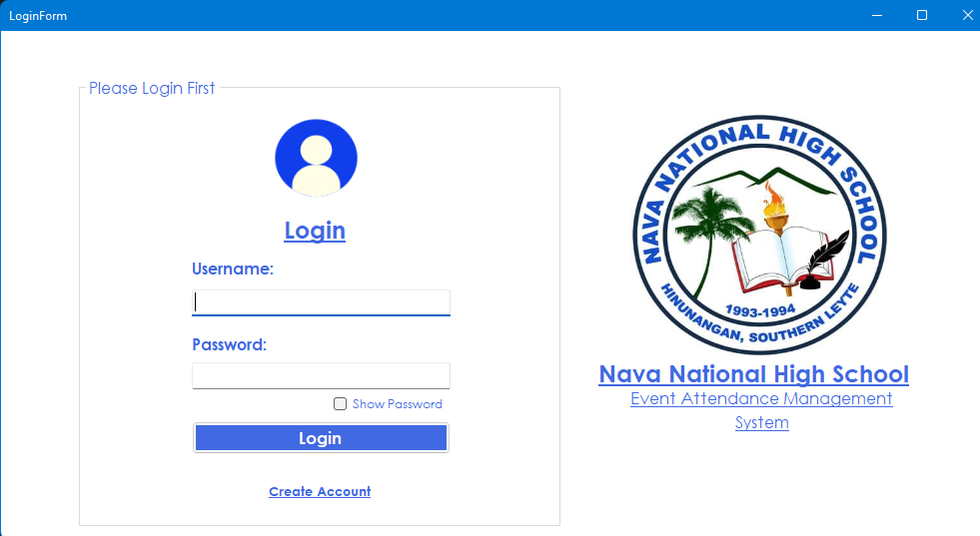

**Main Form**

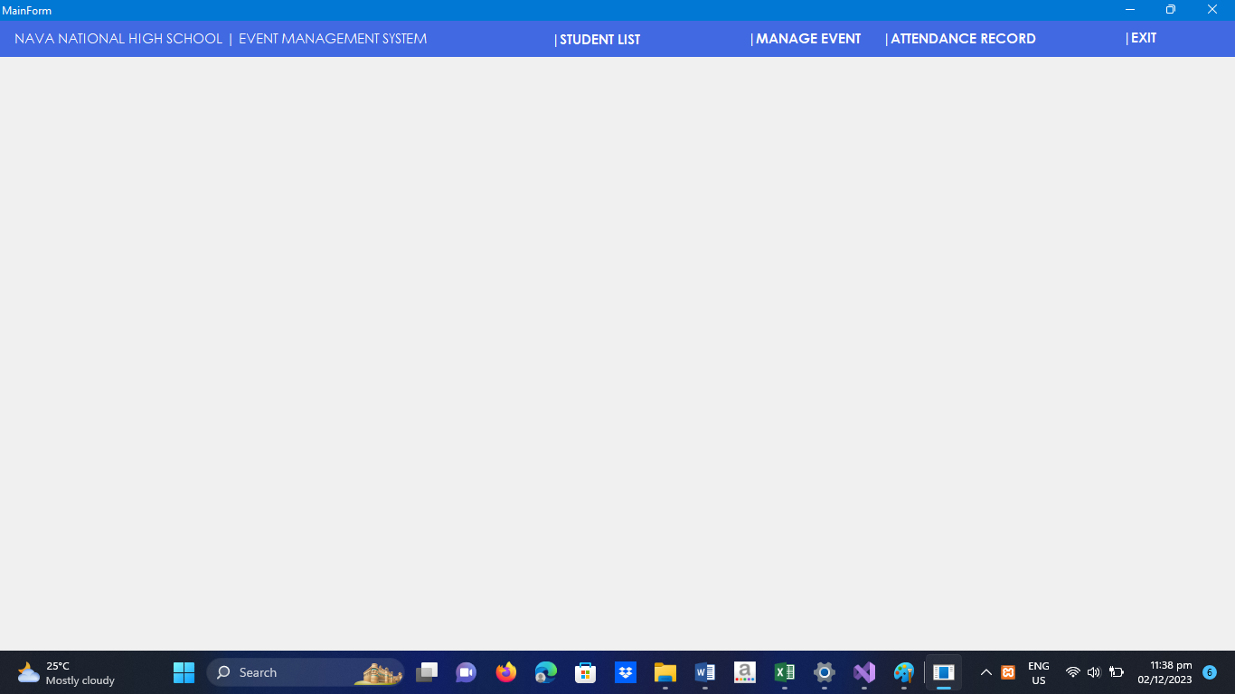

**Student List Form**

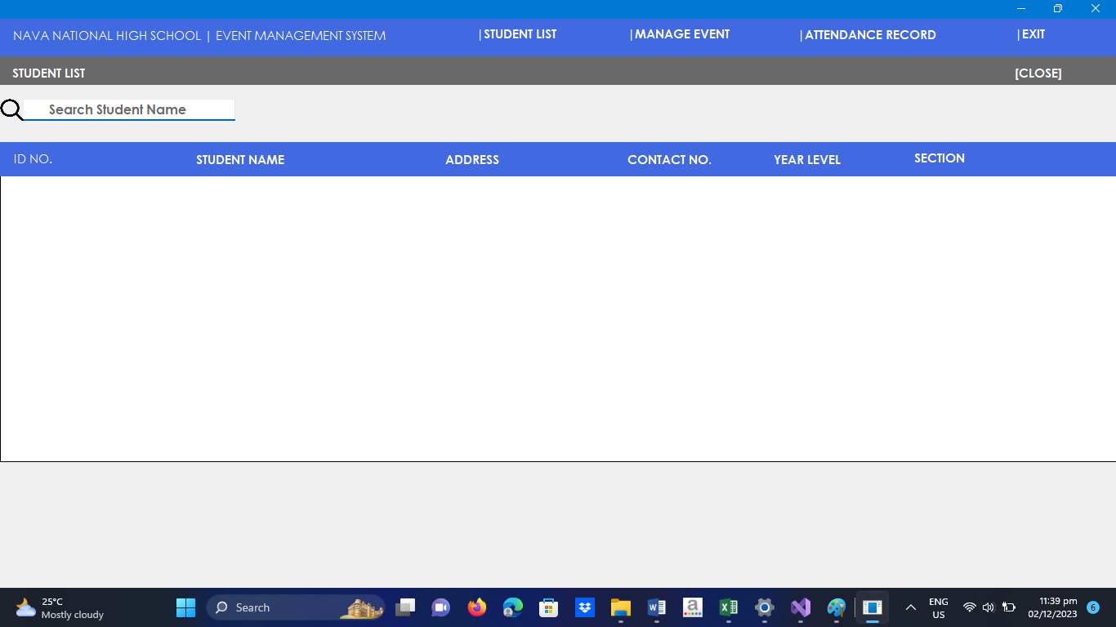

**Manage Event Form**

